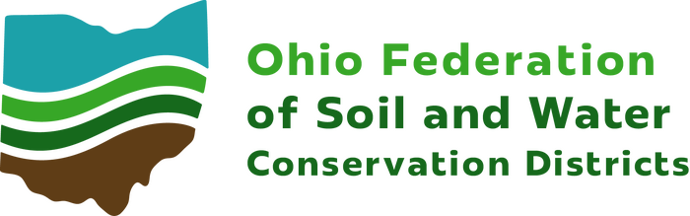
2026
District of the Year

District ____________________________________________________

Phone _____________________________________________________

Address ___________________________________________________

Contact Name _____________________________________________

Email _____________________________________________________

I nominate the above listed SWCD for an Ohio District of the Year Award for Excellence in Soil and Water Education.

Board Chair Signature _____________________________________

Date _____________________________________________________

The purpose of this award is to recognize outstanding and innovative SWCD
education initiatives that have proven successful in reaching out to a variety of
audiences, involving new partnerships and spreading the soil and water
conservation message. District programs honored will serve as models of
excellence for other SWCD education programs.

Eligibility: All Conservation Districts are eligible to participate in this award
unless they have one the award in the previous five years.

Application: To nominate your district complete this form by December 29,
2025.

This award application should be attached to a brief description (500 words or
less) of your SWCD’s success in a specific educational initiative. Up to four
photographs may also be included (please send as a separate attachment for
photo quality)

Applications may be submitted hard copy or electronic by 11:59 pm on Dec. 19, 2025 to:

OFSWCD
Attn: Janelle Mead
8995 E Main Street
Reynoldsburg, OH 43068
jtmead@ofswcd.org

